**Song Studio**

**[Problem Statement]**

Develop a pseudo Frontend application in any tech-stack which should list and play best coke studio songs.

Deployment Link:=> <https://tagmango.vercel.app/>

Screeshots =>

1)Landing Page=> After Clicking go to home you will land to home page

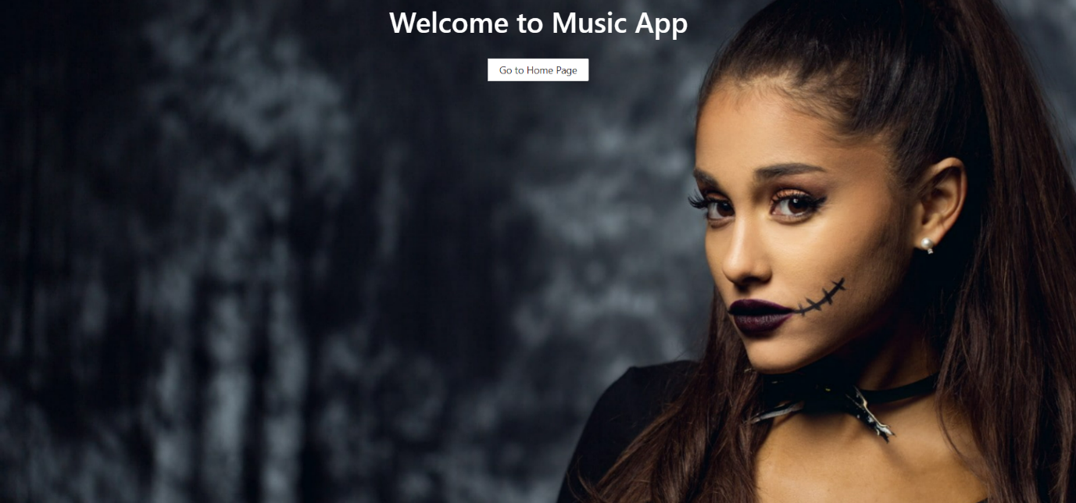

2)Home Page=>This is Home Page

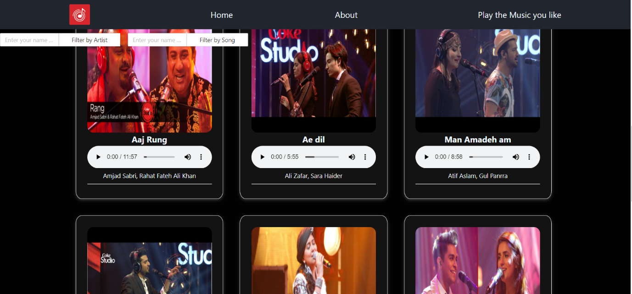

3)Added media Queries =>For mobile view 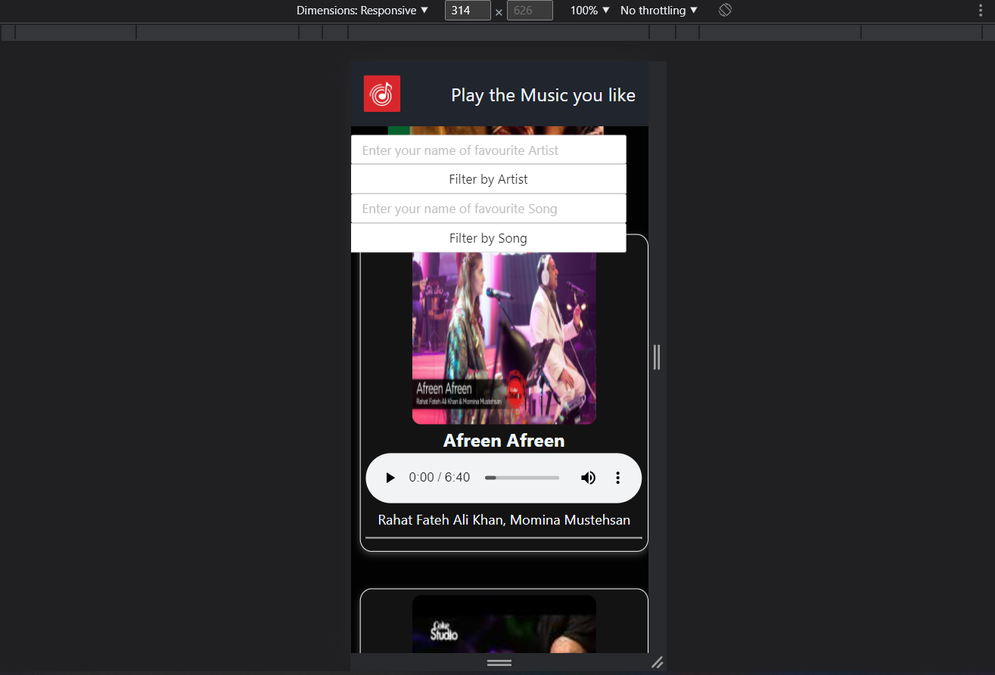

For Tablet View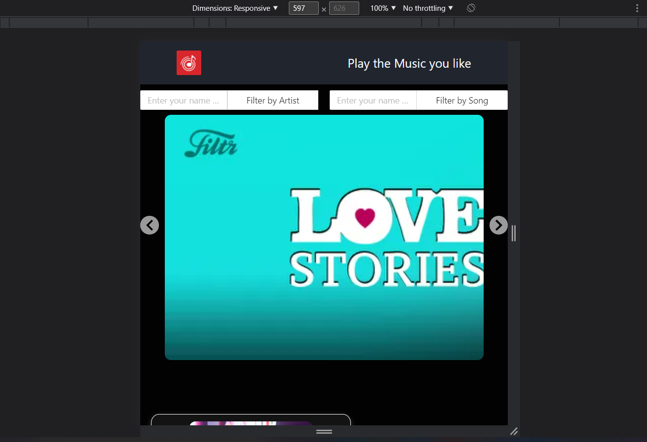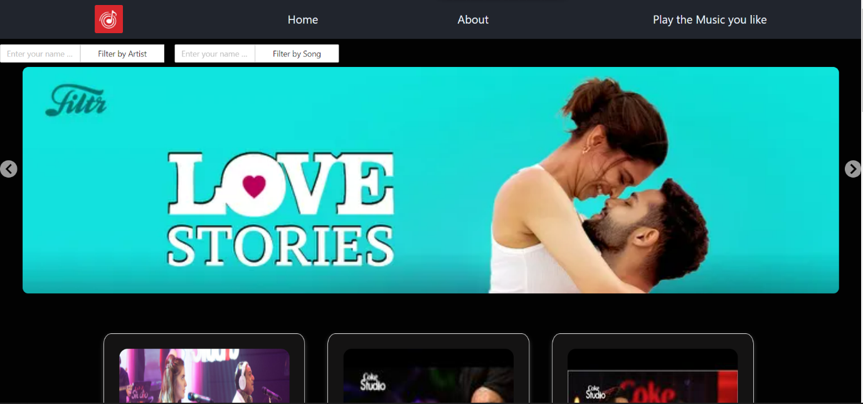

4)Added slider(extra)=>